Incident Description when triggered through API :

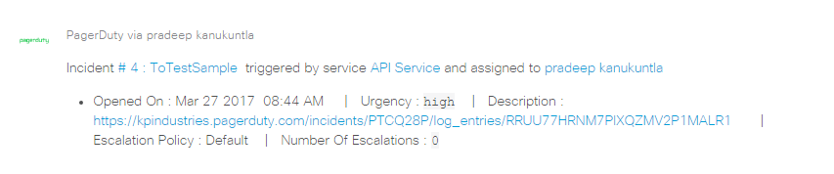

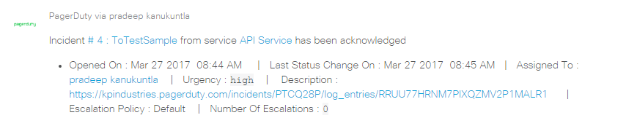

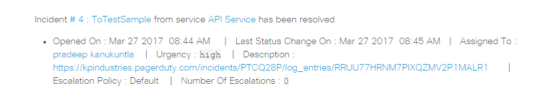

Incidents triggered through web :

